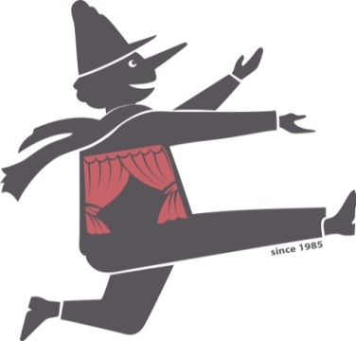 | APPLICATION FORM
THE 35 rd NEAPOLIS INTERNATIONAL FESTIVAL KID'S THEATRES NABEL –TUNISIA
(18 TO 25 DECEMBER 2022)
Name of the Theatre
Address
Telephone no./fax
e-mail

Contact person (organization) + tel.no.
Technical issues (tel)
Title of the performance
Author
Director
Stage designer
Composer
Other authors
Date of premiere
Duration
Intervals
Cast
Age group
Technical requirements
Stage plan | width
 | height
 | depth
Light
Sound
Setting up time | Diassembling time  Montage time |  |  | Rehersal time reqiured  Include in montage tima
Transport mode
Number of people (all) | including | women
 |  | men
 |  | management
 |  | number of vegetarians

PLEASE INCLUDE:
- video ofperformance (linktoview)
- a list with names of team members, including technical staff
- programmers, posters, reviews
- photos
- spectacle synopsis

ATTENTION! The filled form must be sent via email at contact@neapolisfestival.com

The deadline for applications is 15 of July 2022.

